ITALIA SWEET ITALIA
We have a couple of people who would like us to do a third cultural holiday in Italy. If you are interested, please get in touch.
The good news is that Italia Sweet Italia allow a minimum of six people on their tours. This is a 12-day cultural tour based in Vasto, an ancient Roman town overlooking the Adriatic Sea in the Abbruzzo region of Italy.
Tour includes accommodation, meals, airport transfers and activities. I book the transfer to Bristol by chauffeur-driven vehicle (home pick-up) and Easyjet flights to Rome.
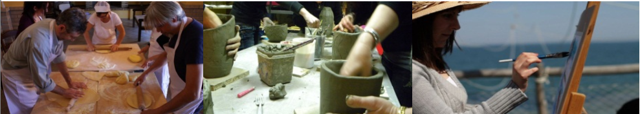
- Classes exclusively for our group in pottery, cooking, painting (or others as requested)
- Visits include a local vineyard, olive oil mill, ceramic museum and bell foundry
